
MCAST Institute for the Creative Arts
AI Use Declaration Form

This form must be completed and submitted with every assignment, as per the department's Academic Integrity and AI Policy. Transparency is essential to proving your creative ownership and learning process.
Part 1: Student & Assignment Details
Student Name: | Andrew Cassar | ID Number: | 0151207L
Unit: | Web Development | Task: | 2
Date: | 15/05/2026

Part 2: Declaration of AI Use
Please select one of the following options:
☐ Option A: No AI Used: I declare that I did not use any generative AI tools in the conception, development, or creation of this assignment. The submitted work is entirely my own.
☒ Option B: AI Used: I declare that I did use AI tools to assist in the creation of this assignment. I have provided a transparent and accurate account of its use in Part 3 below and have submitted all required process work in support of my final submission.

Part 3: Description of How AI Was Used
(Please tick all that apply and provide a brief, specific example for each. For an explanation of each refer to the AI Use Policy Manual)
☐ Ideation & Brainstorming ☐ Research & Summarization
☒ Text Generation & Refinement (Writing/Scripting) ☒ Image/Asset Generation:
☐ Other (Please specify):
Checkout
- I found a code online which I tried and tested to my code, this didn’t end up working after multiple attempts so asked AI using the zip files found online and my own code, to see what I was doing wrong. The tweaks worked but still had some code I didn’t want so removed them and customised it to my preference.

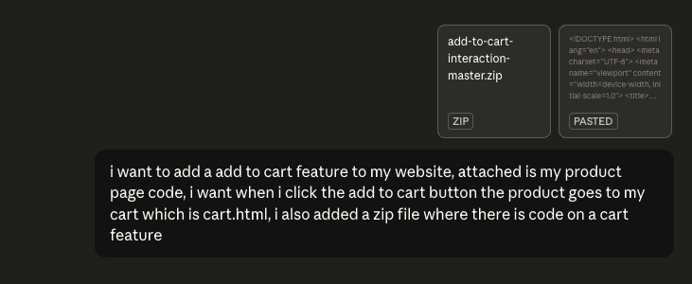
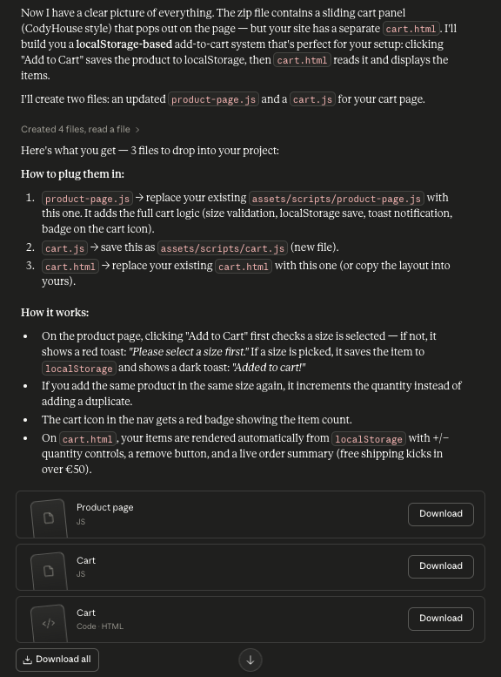

Product Page Placement
- My product pages have a div which is divided into a row of 2 columns, which were divided into a row of a 2x2 grid and a div which had all the product information. I gave AI my code and explained my vision, with also a picture of my existing Figma layout, for how the final version of my Product Page wanted to end up. It explained what I needed to do and with these tweaks I managed to fix my code.
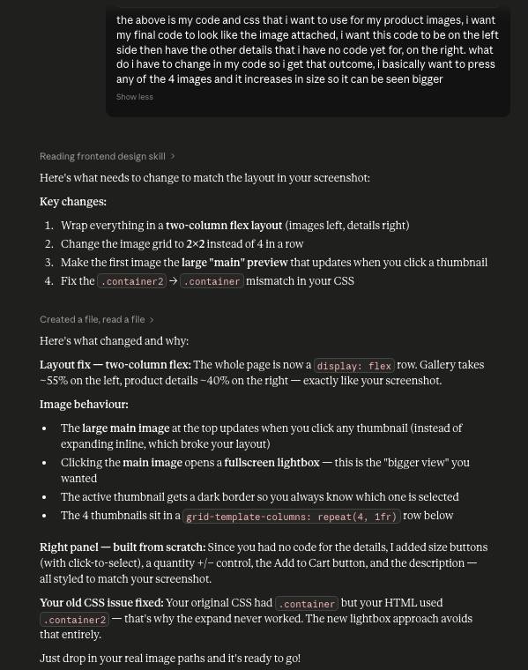

Pages’ Display Image
- World Cup Timer: I found a code for a timer online, but it was not working at all, not even showing up on my website. Therefore, found an example of what I had in mind and asked AI to give me a code. I customised it to my preference and added it to my website.

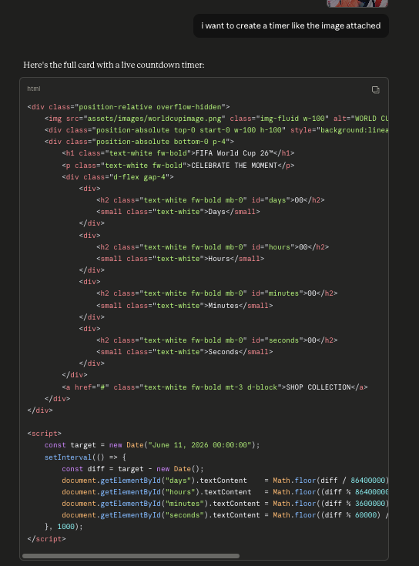

☒ I confirm that I have submitted all required process and development materials alongside my final work, as outlined in the AI Policy.
☒ I confirm that the information provided on this form is a complete and accurate representation of my use of AI tools for this assignment. I have read and understood the Academic Integrity and AI Policy, and I am aware that failing to declare AI use, or misrepresenting its use, constitutes plagiarism and will result in disciplinary action.
Print to PDF and include in your submission once completed.

